**WORD CLOUD & SENTIMENTAL ANALYSIS**

**Business Problem** = ﻿﻿﻿﻿﻿﻿Extracting reviews of Speaker from amazon and performing sentimental analysis..

* **Name of Product : -** Portronics Sound Drum 4.2
* **Website : -** Amazon.in
* **Review URL : -** ﻿https://www.amazon.in/product-reviews/B07B2XRFRV/ref=acr_

dpproductdetail_text?ie=UTF8&showViewpoints

* **Review Extracted : -** 430

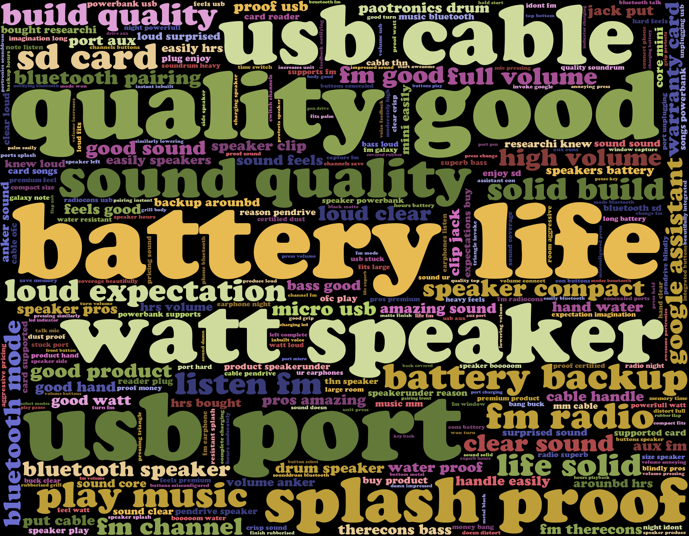**Word Cloud** =

From the Above word cloud, we can observe some words which are giving us some inside about properties or characteristics of Portronics Sound Drum as follows.

1. This is a **Good Quality** product with High **Battery life** as well as **Battery Backup**.
2. The **Speaker** has **Bluetooth Mode, USB Port, FM Radio**, and also supports **SD Card**.
3. The sound quality of the Product is **loud clear**.

After seeing the above word cloud we can say that this is a good product and customer giving a positive response against the product.

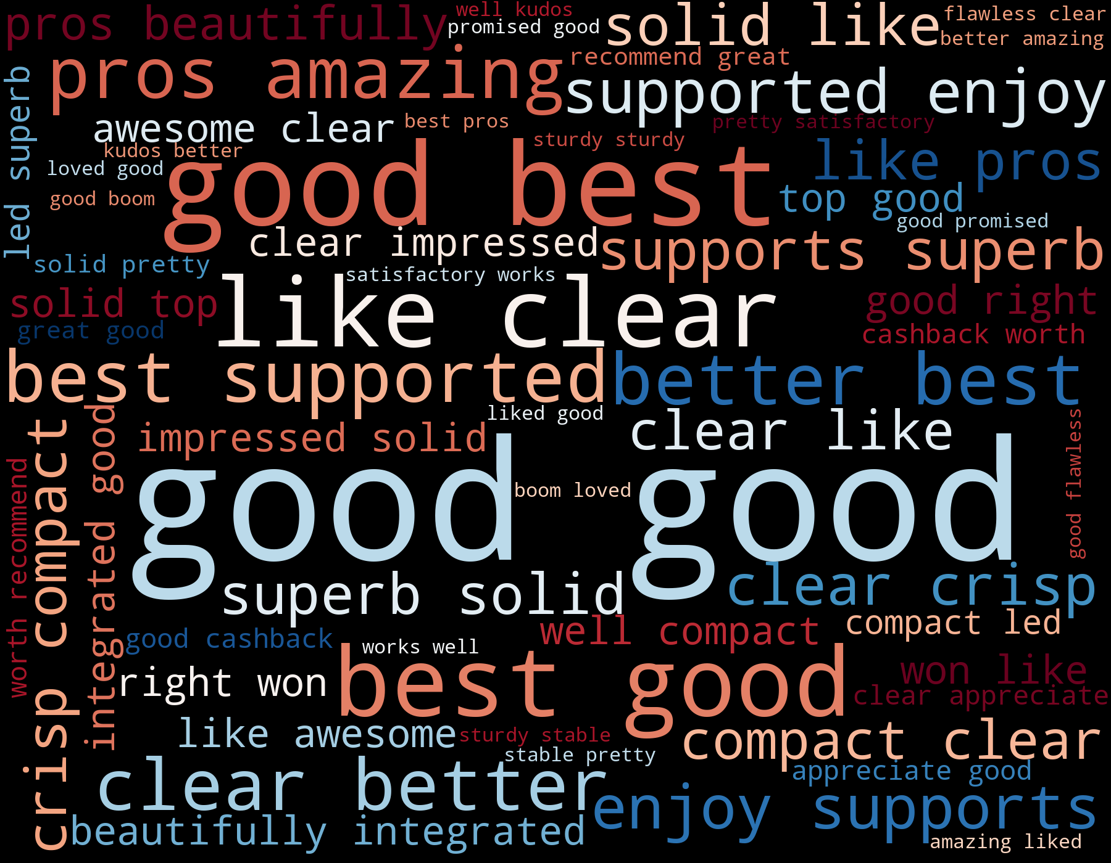**Positive Sentimental Analysis =**

This all are positive responses of customer on Portronics Sound Drum.

**Negative Sentimental Analysis =**

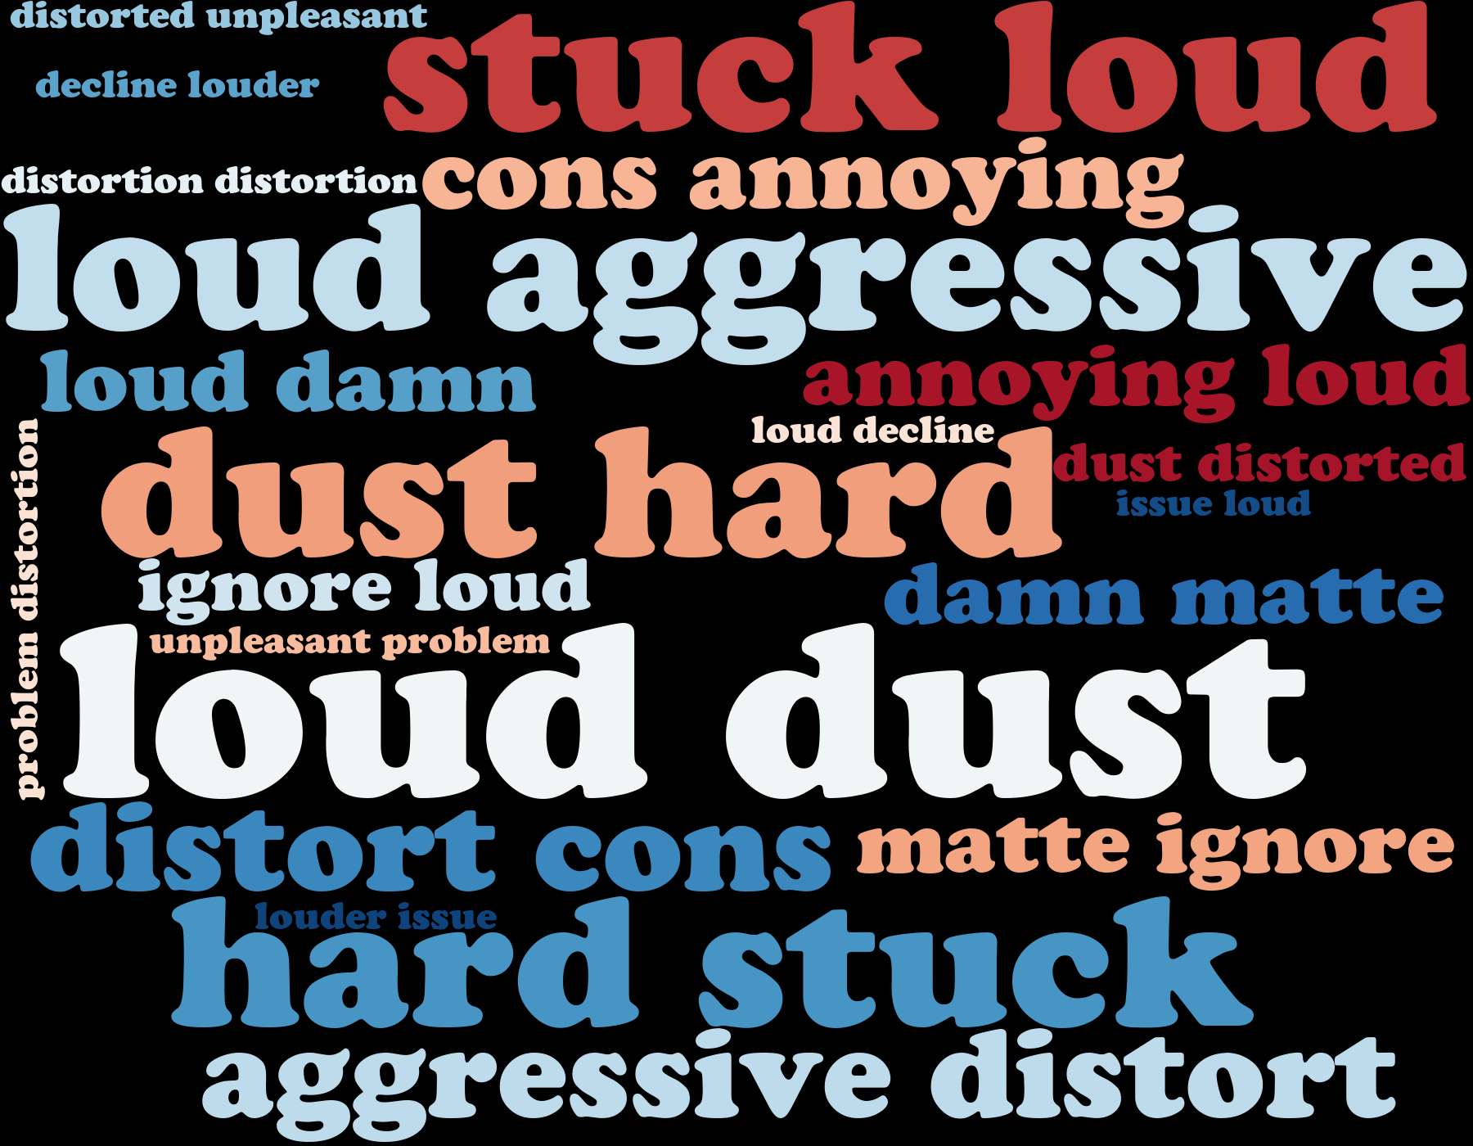

Speaker has some Drawbacks which we can clearly observe in above negative sentimental Word Cloud .

**Python code file**: - [Amazon Word Cloud (Bluetooth Speaker).py](https://github.com/nilaydeshmukh0/Text-Mining-and-Sentiment-Analysis/blob/master/Amazon%20Product%20Analysis/Amazon%20Word%20Cloud%20(Bluetooth%20Speaker).py)